Reprogramming Fibroblasts into Bipotential Hepatic Stem Cells by Defined Factors

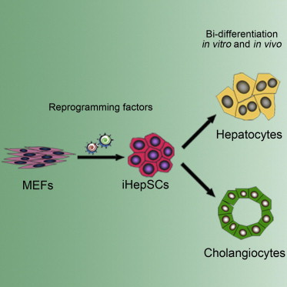

Summary
Recent studies have demonstrated direct reprogramming of fibroblasts into a range of somatic cell types, but to date stem or progenitor cells have only been reprogrammed for the blood and neuronal lineages. We previously reported generation of induced hepatocyte-like (iHep) cells by transduction of Gata4, Hnf1α, andFoxa3 in p19 Arf null mouse embryonic fibroblasts (MEFs). Here, we show that Hnf1β and Foxa3, liver organogenesis transcription factors, are sufficient to reprogram MEFs into induced hepatic stem cells (iHepSCs). iHepSCs can be stably expanded in vitro and possess the potential of bidirectional differentiation into both hepatocytic and cholangiocytic lineages. In the injured liver of fumarylacetoacetate hydrolase (Fah)-deficient mice, repopulating iHepSCs become hepatocyte-like cells. They also engraft as cholangiocytes into bile ducts of mice with DDC-induced bile ductular injury. Lineage conversion into bipotential expandable iHepSCs provides a strategy to enable efficient derivation of both hepatocytes and cholangiocytes for use in disease modeling and tissue engineering.

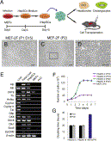
Figure 1. Conversion of MEFs into iHepSCs by Hnf1β andFoxa3(A) Schema of the experimental procedures including direct induction of iHepSCs by defined factors, in vitro differentiations, and in vivo cell transplantation assays.(B) Representative epithelial clone emerged from the MEFs at 15 days postinfection with Hnf1β and Foxa3(passage 1).(C and D) The same epithelial clone shown after expansion (passage 2) (C), and the outlined area in (C) was magnified to show converted morphology of epithelial cells in the clone (D).(E) RT-PCR results for detection of hepatic gene expressions in the converted epithelial cells, adult liver cells, fetal liver cells, and MEFs were used as controls.(F and G) Growth curves (F) and cell doubling times (G) for two iHepSC clones, iHepSC-2 and iHepSC-6 (both passage of 10 and passage of 30), in comparison with MEFs (passage 4). Data represent mean ± SD (n = 3). P, passage number; D, days after passage of cells. Scale bar represents 100 μm.See alsoFigure S1 and Table S1.
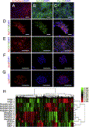
Figure 2. Characterizations of iHepSCs(A–C) The expressions of E-Cadherin (A), EpCAM (B), and Pan-CK (C) in iHepSCs were recognized by assay of immunostaining.(D and E) The coexpression of Alb and CK19 (D) and Afp and CK19 (E) in the iHepSCs was found by immunostaining.(F and G) The expression of Sox9 (F) and Lgr5 (G) in an expanding clone of iHepSCs was found by immunostaining.(H) Hierarchial clustering analysis of global gene expression profiles to compare iHepSCs with other relative cells. Scale bar represents 100 μm.See also Figure S2 and Table S2.

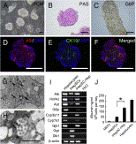
Figure 3. iHepSCs Differentiated into Mature Hepatocytes In Vitro(A) Representative aggregates formed by iHepSCs after hepatic differentiation.(B and C) Glycogen storage (B) and Glucose-6-phosphatase (G6p) activity (C) found in iHepSC-derived hepatic cells by assay of PAS staining and chiquoine staining, respectively.(D–F) iHepSC-derived hepatic cells lost the expression of cholangiocyte marker CK19 (E) and only expressed Alb (D). (F) merged picture of (D) and (E).(G and H) Ultrastructure of iHepSC-derived hepatic cells showed the morphological features of mature hepatocytes, including well-developed organelles and intercellular canaliculi. Arrowheads and arrows in (G) indicate lysosomes and mitochondria, respectively. Arrowheads and arrows in (H) indicate sites of tight junctions and glycogen granules, respectively.(I) The comparisons among iHepSC-derived hepatic cells (iHepSC-Heps), iHepSCs, and primary hepatocytes for the expressions of representative genes relative to both hepatocytes and cholangiocytes by RT-PCR analysis.(J) ELISA showed the significant levels of secretory Alb by iHepSC-Hep, and the data were represented as mean ± SD (n = 3;∗p < 0.05, LSD t test). Scale bar represents 100 μm in (A)–(D) and 1 μm (E) and (F).

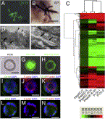
Figure 4. iHepSCs Differentiated into Cholangiocyte In Vitro(A) CK19 immunostaining on the representative branching structures formed by the iHepSC-derived cells cultured in the 3D collagen type-1 gel.(B) Staining for alkaline phosphase activity in the iHepSC-derived cells that formed branching structures (purplish red).(C) Hierarchical clustering heatmap of 17,746 genes from Primary Cholangocytes (P-Ch-1 and P-Ch-2), iHepSC-derived cholangiocytes (iHepSC-2-Ch and iHepSC-6-Ch), and iHepSCs (iHepSC-2 and iHepSC-6). iHepSC-derived cholangiocytes clustered with primary cholangiocytes.(D and E) Ultrastructure of basement membrane (arrow) and microvilli (arrowhead) of iHepSC-derived cells for detection of cholangiocytic differentiation. (E) Magnification of the outlined area in (D) showed the details of basement membrane (arrow) with typical feature of cholangiocytes.(F) Morphology of the iHepSC-derived ductal cysts formed in a 3D culture system.(G) Transport of rhodamine 123 (Rho-123) into the central lumen of a cyst.(H) The MDR inhibitor verapamil (Ver) blocks rhodamine 123 transport.(I–K) Coimmunofluorescence staining for CK19 (I) and F-actin (J). (K) shows a merged picture of (I) and (J).(L–N) Coimmunofluorescence staining for CK7 (L) and F-actin (M). (N) shows a merged picture of (L) and (M). Scale bar represents 100 μm in (A), (B), and (F)–(N) and 1 μm in (D) and (E).

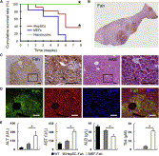
Figure 5. Engraftment of iHepSCs into the Liver Parenchyma and In Vivo Differentiation into Hepatocytes(A) Kaplan-Meier survival curves of hepatocyte-transplanted Fah^{−/−} mice (n = 6), iHepSCs-transplanted Fah^{−/−} mice (n = 11), and MEFs-transplanted Fah^{−/−} mice (n = 6) after NTBC withdrawal. Log rank test revealed differences between the curves for iHepSCs and MEFs (p < 0.05) and iHepSCs and hepatocytes (p < 0.05).(B) Fah staining of repopulated iHepSCs nodules in liver sections.(C) Histological analyses showed that the engrafted hepatocytes in livers of Fah^{−/−} mice were positive for Fah protein expression and showed normal hepatocyte morphology in H&E staining. Arrows indicate binucleated hepatocytes.(D) The repopulation nodules of iHepSC-derived hepatocytes in livers of Fah^{−/−} mice recipients coexpressed Alb and Fah by immunofluoresence staining.(E) Biochemical analysis of metabolic function of Fah^{−/−} recipients. The levels of ALT, AST, ALB, and total bilirubin in WT mice (n = 4), Fah^{−/−} recipients repopulated by iHepSC-derived hepatocytes (n = 4), and Fah^{−/−} mice transplanted with MEFs (n = 4) are shown. The data are represented as means ± SD. ∗p < 0.05, LSD t test. Scale bar represents 100 μm.See also Figure S3.

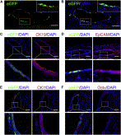
Figure 6. Engraftment of iHepSCs into the Bile Ducts and In Vivo Differentiation into Cholangiocytes(A) Discontinuous distribution of iHepSC-derived cells labeled by eGFP in the large bile ducts of livers in DDC-treated mice after transplantation.(B) Nuclei in (A) were counterstained with DAPI.(C) The eGFP-positive iHepSC-derived cells found in large bile ducts expressed cholangiocyte marker CK19 by immunofluoresence staining.(D and E) The eGFP-positive iHepSC-derived cells found in large bile ducts expressed cholangiocyte marker EpCAM (D) and CK7 (E) by immunofluoresence staining.(F) The eGFP-positive iHepSC-derived cells found in large bile ducts expressed cholangiocyte functional marker Ostα expression by immunofluoresence staining. Scale bar represents 100 μm.See also Figure S4.

